


How to cancel the Pipeline Wizard



Document Control Information
Document Information
Document Name | Steps to be followed to cancel the Pipeline Wizard
Client | Humana
Document Author | Rohit Kumar Saini
Document Version | 1.0
Document Status | Release
Date Released | 10/19/2021
Document Edit History
Version | Date | Additions/Modifications | Prepared/Revised by
Document Review/Approval History
Date | Name | Organization/Title | Comments

Table of Contents
1 Overview 4
Audience 4
Purpose 4
Assumptions 4
2 Pipeline Manager Overview 5
3 How to cancel the Pipeline Wizard 6

Overview

Audience
The intended audiences are technical designers and developers of the Copado platform. ‘Developers’ include anyone who work on Copado platform and is not isolated to developers working on implementing a single project.

Purpose
The Purpose of this document is to outline the steps need to be followed to get rid of the Pipeline Wizard page they see when they click on Pipeline Manager tab.

Assumptions
It is assumed that the reader has the knowledge of how to Configure Pipelines and manage them accordingly based on the requirements.
The reader of this document has the basic knowledge of Copado platform.

Pipeline Manager tab issue Overview

The Pipeline Manager is a unidirectional flow that defines the order in which changes will be migrated, starting with the development orgs and finishing in a production org and it also gives the flexibility to configure pipelines if required by the user. Recently few users have experienced an issue with the Pipeline Manager tab as it should show the existing pipelines as the expected behavior whenever the user clicks the tab instead it started creating new pipelines everytime when user clicks on the pipeline manager tab. So, we had a call with Copado support team and was navigated to perform few steps to avoid creating the new pipelines by cancelling the pipeline Wizard.

Please follow below steps to cancel the Pipeline Wizard as a one time process when the user face the issue and then the issue should be resolved and the user should see the existing pipelines after a successful logout and login.

Issue Screen shot

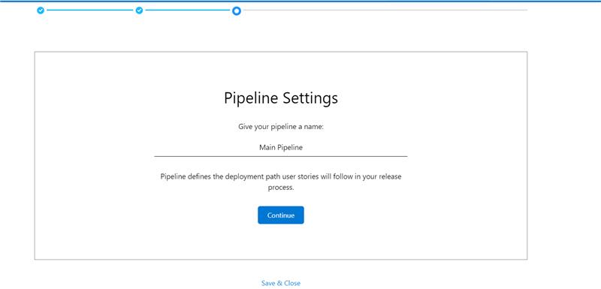

How to cancel the Pipeline Wizard

1. When you are on that page where it says, "Give your Pipeline a name:", give any name and press Continue. It should have taken you to the next step where it tells you to provide a Git Repository Name.

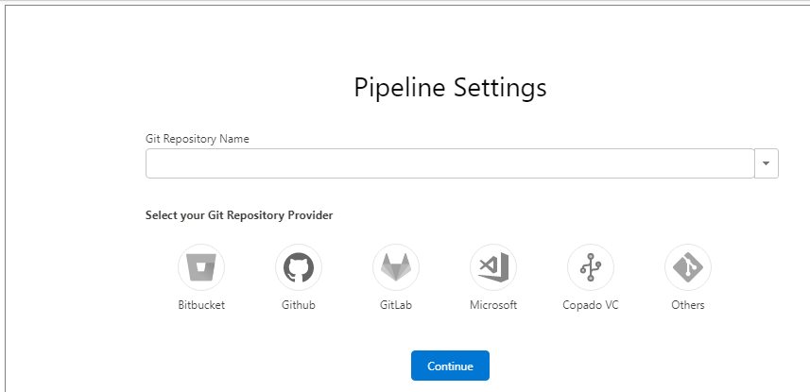

2. Do not press Continue, Click on the Pipelines Tab and click on "New" and then click on "Start New" once the pop-up appears. It should have taken you back to start of the Pipeline Wizard.

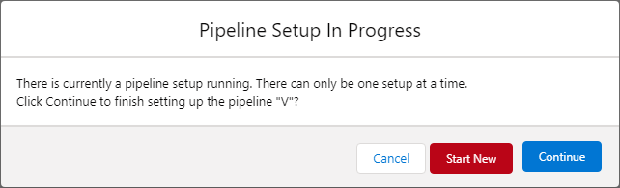

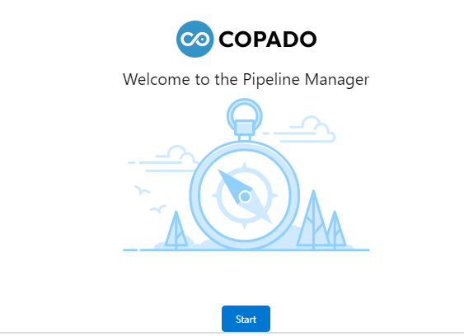

3. Do not press Start, Go to the Pipelines Tab again and then delete the Pipeline that was just newly created.

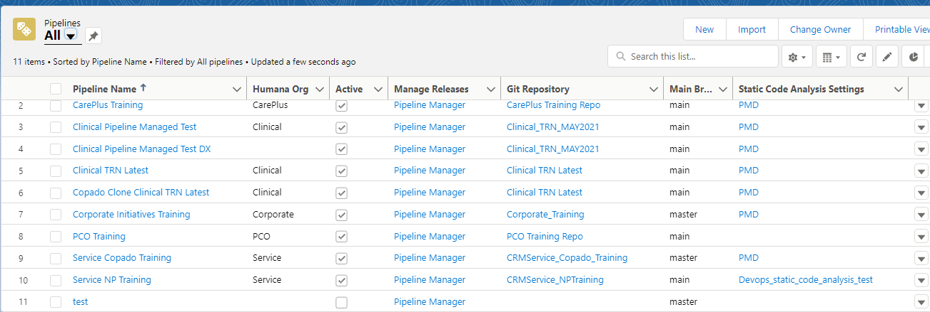

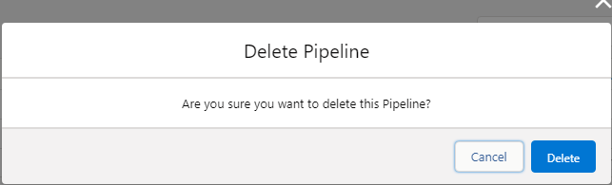

4. If you click on the Pipeline Manager Tab, you should now see your active Pipelines.

